IRMA Overview
Founded in 2006 by a coalition of nongovernment organizations, businesses purchasing minerals and metals for resale in other products, affected communities, mining companies, and trade unions, the Initiative for Responsible Mining Assurance (IRMA) is developing a global standard for certification of environmental and social performance related to industrial-scale mining, including labor rights, human rights, indigenous peoples and cultural heritage, conflict response, pollution control and site reclamation.
Mining is a complex and intensive process that causes environmental and social change no matter where it occurs. IRMA's vision is that of a world in which the mining industry respects human rights and the aspirations of affected communities; provides safe, healthy and respectful workplaces; avoids or minimizes harm to the environment; and leaves positive legacies.
IRMA’s mission is to establish a multi-stakeholder and independently verified responsible mining assurance system that improves the social and environmental performance of mine sites around the world.
Terms of Reference
IRMA seeks contract assistance for the purpose of developing and implementing an assurance program that includes independent third-party auditing of mine sites against the Standard for Responsible Mining for the purpose of certification.

Background:
In 2012, IRMA’s Steering Committee reviewed four possible models on which to base IRMA’s assurance program. IRMA’s Steering Committee sought to strike a balance between retaining some authority for oversight and quality assurance, while also recognizing the complexity and breadth of the global environment in which industrial-scale mine sites applying to IRMA operate, and so they selected the verification model “2.5” (see diagram).
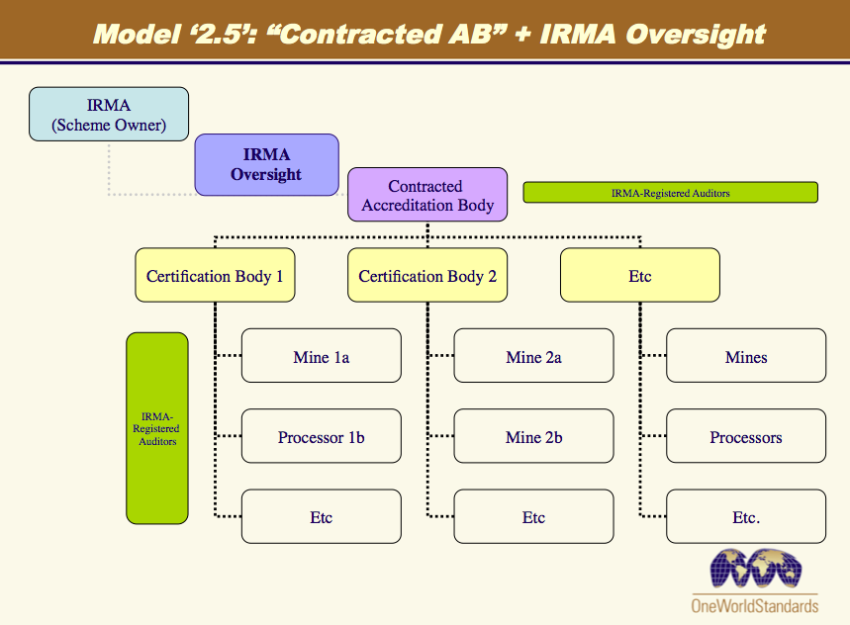
At the time when IRMA’s Steering Committee adopted model 2.5 in principle, IRMA did not yet have a draft Standard for Responsible Mining. IRMA has since released two drafts of its Standard for Responsible Mining for public comment, and is in the process of preparing a final version of the Standard based on stakeholder input and field testing of the Standard that took place in 2015 and 2016.
The IRMA Standard is comprehensive, covering 27 topic areas under the broad headings of Business Integrity, Social Responsibility, Environmental Responsibility, and Positive Legacies. Some of the environmental chapters, in particular, are fairly technical, and may require some focused auditor (inspection body) training and, at least initially, some fairly close oversight.
IRMA expects to begin certifying mine sites in the 3rd Quarter of 2017. Rather than implementing a full model 2.5 assurance system, IRMA is contemplating launching its certification system using an interim, scaled-back assurance system whereby IRMA would retain oversight of inspection bodies, and perhaps retain certificate review or decision-making authority. A scaled-back assurance system is being contemplated for a number of reasons: 1) to provide learning to inform whether or not IRMA eventually wants to adopt a full-blown model 2.5 assurance system; 2) it is anticipated that the design and implementation of a scaled-back system may be more realistic given the goal of launching IRMA’s certification system in the 3rd Quarter of 2017.
IRMA recognizes that for all of its stakeholders its assurance program will be nearly, if not just, as important as the performance expectations described in the Standard itself. How a mine site is evaluated on the ground, the training and quality of the auditors, and the relationship between IRMA and its verification partners will be essential to assuring that IRMA’s mission is being implemented as intended. Consequently, whatever assurance model IRMA adopts must be be credible to its stakeholders.
Scope of Work
IRMA seeks the contract assistance of a consultant or firm/organization to assist the IRMA Secretariat in developing and implementing an interim assurance system that will become operational in the 3rd Quarter of 2017.
A first step in this effort will be preparing from one to as many as three options for an interim assurance system that the contractor determines could be: 1) implementable in the next six to eight months; 2) credible to IRMA stakeholders; and 3) compliant with the ISEAL Assurance Code. These options will be presented to the IRMA Steering Committee in New York in late February 2016.
Following a decision by the IRMA Steering Committee on an interim assurance model that best fits IRMA’s needs, the contractor will work with the IRMA Secretariat to develop and implement the assurance program.
Contract work to include:
- A report to the IRMA Secretariat describing recomended option(s) for IRMA’ interim assurance program
- Presentation of option(s) to the IRMA Steering Committee at a meeting in New York on 27/28 February 2017
- A workplan with timeline and budget for the development and implementation of IRMA’s assurance program
- Working with the IRMA Secretariat to implement the first phases of the assurance program

Outside of the scope of this contract, but a consideration for future scope of work would be an evaluation of the effectiveness of the interim assurance program, and working with the IRMA Secretariat and governance body to develop a final assurance model based on the learning from the interim assurance sytem.
Timing
Contractor to develop option(s) for an interim assurance system by 10 February, to be reviewed by Secretariat the following week, and presented to the IRMA Steering Committee on the 27 or 28 of February in New York.

Development and implementation of the assurance system option approved by the IRMA Steering Committee will take place from 1 March to approximately 1 September, when it is anticipated that the IRMA certification system will be launched.

Assuming that there will be parts of the implementation phase that may involve the contractor beyond the actual launch of the IRMA certification system, contract assistance may extend through 2017, and into 2018, as agreed by IRMA and the contractor.

Point of Contact
In providing this contract assistance, consultant will use IRMA Coordinator Aimee Boulanger as lead point of contact and support: aboulanger@responsiblemining.net.

